COMP-152 Project 1
Summer 2023
Digits game

Objective:

Your task is to recreate the New York Times Digits game. You can play it here https://www.nytimes.com/games/digits , at least until they remove it on August 8. Before starting your project, try playing the game.

A screenshot of the game and its help page are below:

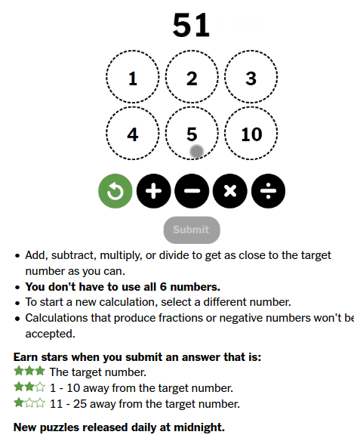
Help screen: https://www.nytimes.com/games/digits
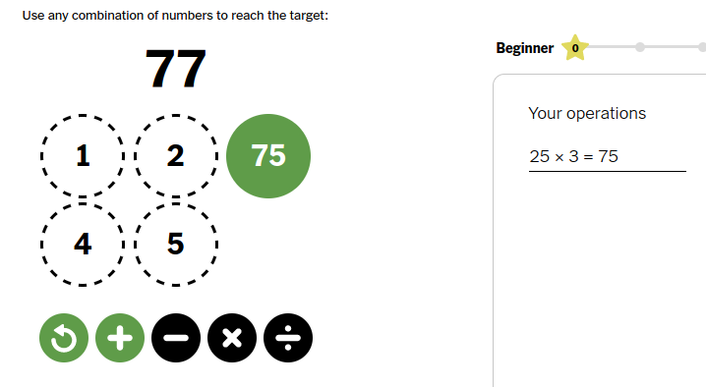
Mid-game: I clicked on the 25, then x, then 3, and the 3 turned to 75

You are not expected to reproduce this entire game exactly! (Unless, of course, you want to try to.)

Step 1: Mock-up

Make a mock-up of this game with all the core graphical components to play a round. Your mock-up should include:

- a window (size it 500 by 500, or similar)
- a label showing a target number
- six number buttons, each showing a number . At this stage, just hard-code a number of your choice
I recommend using a for-loop here
- four operator buttons: +, -, x, / (Don’t bother with Undo)
- a text area listing the operations you’ve done so far (I recommend something like 6 rows, 30 columns)

You may use any of the following Java Swing classes: JFrame, JButton, JPanel, JTextArea, JLabel

Hint: make an inner panel to hold the six number buttons, another to hold the four operator buttons, and an outer panel to hold the label, the two inner panels, and the text area. Then add the outer panel to the window.

Your mock-up may look like this:
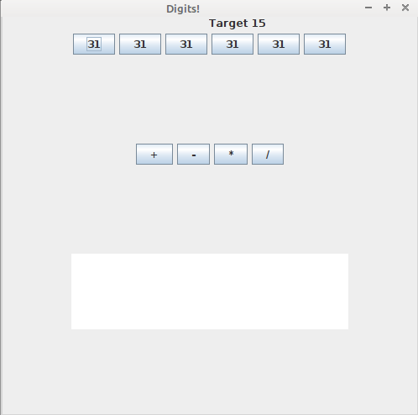

Step 2: Make actions happen

Add an ActionListener to each button.

In the number buttons, have your action listener print out (just use System.out.println) the number in the button using .getText(); Do the same for the operator buttons.

When you run it now, every button should print out its content to the console when you press it.

Step 3: Get the numbers

At the end of this step, you should be able to press a number, an operator, and a number, and your code should remember it.

You can do this as follows:

1. Make a global variable public static int step = 0;
Make another global variable public static int computation = 0;
Make a third global variable public static int firstnumber=0;
Make a fourth global variable public static int secondnumber=0;
Make a global char variable public static char operation;

2.
Inside each number button’s action listener, do this:
- if step is 0, save the button’s number as follows:

firstnumber = Integer.parseInt(numberbutton.getText())

and set step to 1

- if step is 2, save the button’s number into secondnumber

- and set step to 0

3.
Inside each operator button’s action listener, do this:
do this only if step is 1:
set variable operation to '+', '-', 'x', '/' as appropriate
set step to 2

Make sure you add System.out.println to your code under each if statement so you can see if it works.

Step 4: Make math happen

Go back into each number button’s action listener. Only when step is 2, after you save the second number, you can do the operation. Your code might look like this:

- if step is 2:
[your code to save secondnumber and set step to 0 is here]

- if operation is '+'
set computation to firstnumber + secondnumber
print out computation
change the button’s text to the computation:

numberbutton.setText(""+computation);

Repeat this for all four operations

Step 5. Show your work

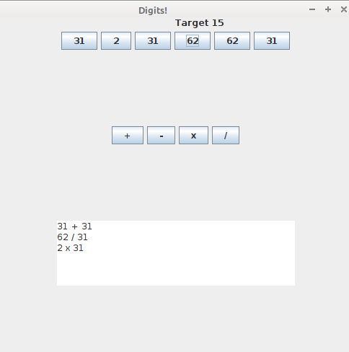

When you do the operation (still inside of the number button’s actionlistener) , make your TextArea show the math expression. For example, if you pressed 31, +, 31, your TextArea should show “31 + 31 = 62 \n” (Notice the \n will show up as a new line)

Use the function .append to change the text so that you see all the previous operations

Step 6. Check for victory

Make a global variable static int target=2;

In main, when you make your “Target: “ label, show the number in target rather than hardcoding a number.

After you do the computation, in your number button’s actionlistener, check if the computation == target. If so, change the target label’s text to something like “You Win!” You might also set step=3 so that nothing else happens when you press buttons.

Hint: you can test this: if all your number buttons have the same number, add two number buttons together, then divide that number button by another to get 2.

Step 7. Make the number button disappear

When you do a computation, make the first number button you pressed disappear. You can do this as follows:
- make a global variable static JButton firstnumberbutton
- when you set firstnumber, also set firstnumberbutton to the number button
- when you do the operation, call
firstnumberbutton.setVisible(false);

Step 8. Choose your numbers

In main, before you make any graphics, make an array of numbers. For example:

int[] values = new int[] { 3, 5, 7, 9, 11, 15 };

When you initialize your number button, assuming you did it in a for (int i=0; i<6; loop, set the button’s text to "" + values[i]

Now you should be able to make your own puzzle. Today’s New York Times game is 1, 2, 3, 4, 5, 25, and the target is 77. Can you make your program do this?

Bonus steps:

I will give bonus points if you manage to do any or all of these. Please note: I won’t give bonus unless 1. the core project is completed, and 2. the bonus step you attempted actually works.

Bonus 1: Make random numbers and an achievable target

Use Math.random to make six random integers. Then make a target. The challenge here is that your target should be reachable. You might do this by making a for loop, choosing an operation + - * / at random, do the computation, and then set the target when you’re done.

Bonus 2: Make an Undo button

This is challenging. Make three global arrays of size 6: two to hold buttons changed, and another to hold button texts you changed. Keep a global counter of how many operations you did. Every time you do an operation, before updating the buttons, save the firstbutton in one array and the second button’s text in the second, and increase the counter.

For example,
buttonhid[counter] = oldbutton;
buttonchanged[counter] = numberbutton;
buttontext[counter] = numberbutton.getText();
counter=counter+1;

Now make one more button called Undo. If that button is pressed, subtract 1 from counter (assuming it’s > 0), use the first array to unhide a button, and the second to change the button’s text back to the text in the third array.

You might also put something in the TextArea, for example, “Undid last operation” or even better, remove the last line from the textarea altogether.

Bonus 3: Graphics
Make the graphics look more like the original game. This will use information we haven’t yet done in class. My way would be to make a subclass of JComponent, draw six ovals and labels, and add a mouselistener to simulate a button press.

Grading

You submit working code and demo it to me 40%
Step 1 60%
Step 2 65%
Step 3 70%
Step 4 80%
Step 5 85%
Step 6 90%
Step 7 95%
Step 8 100%

Each Bonus +10% - 20% depending on how well it works

